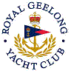 | Royal Geelong Yacht Club Inc.  Est 1859
Trophy Deed of Gift.

Trophy: | Reg and Alan Taylor Trophy
Presented by: | Taylor Family
Date:
For: | Most Improved Div I Yacht
Remarks / Revisions | Glass model of “Winston Churchill”

